|  |  |
| --- | --- |
| Course Name | ITD 2313 – Script Programming |
| Instructor | Mark Pranger |
| Student Name | Josh Jones |
| Due date | July 21 |
| Grade | <grade earned here> |
| Grading Comments | <instructor comments here> |

Page 209:

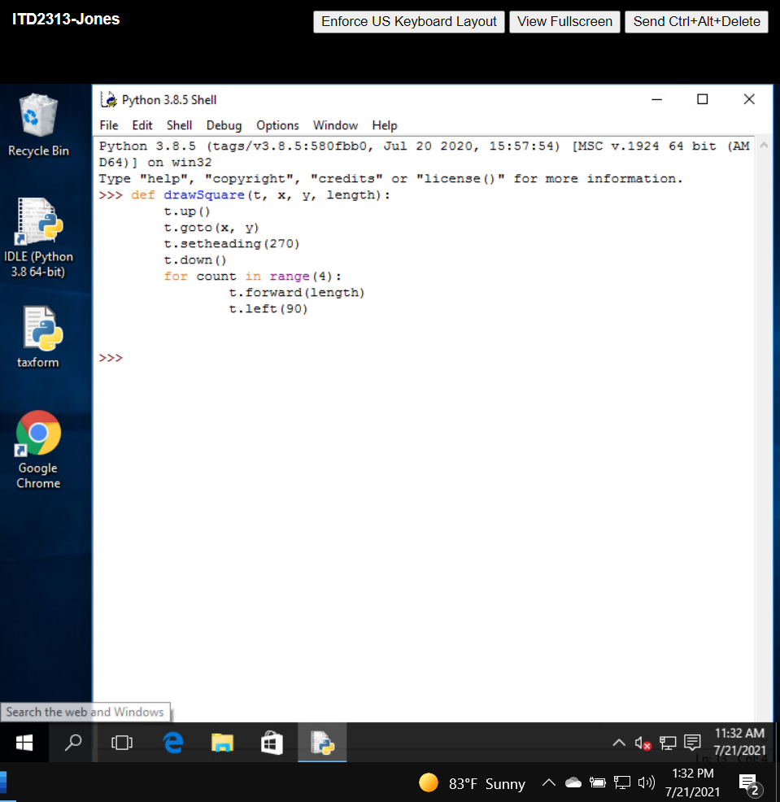

Page 210-211:

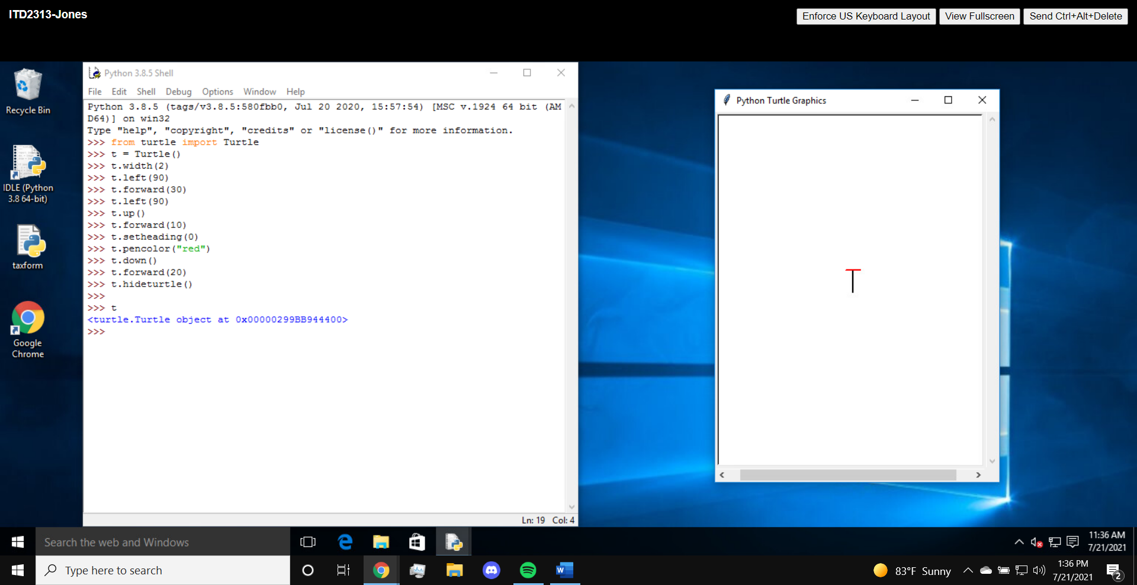square

Page 212:

Page 213:

Page 214-215:

Page 226:

Page 227:

Page 228:

Page 230:

Page 233: